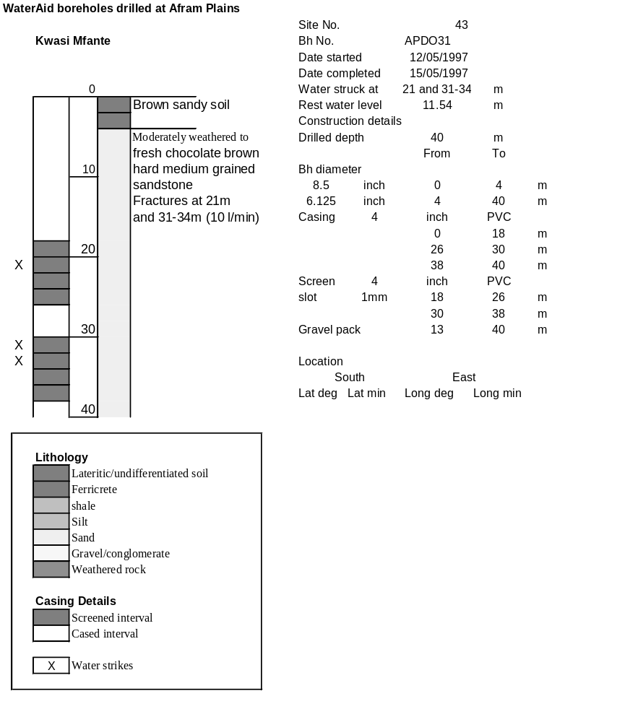

Ghana | Test pumping
Borehole No. |  | APDO 31
Hole No |  | 43
Village |  | Kwasi Nfante IV
Date |  | 08/06/1997
Point below GL |  | 0.1 | m
Pump depth |  | 24 | m
SWL |  | 11.44 | m
Start Time |  | 20:00
Drawdown test |  |  |  |  | Recovery Test
time | pwl (m) | Q l/min | dd | sc(q/s) | Time | wl (m) | t/t' | resdd
0.00 | 11.44 | 4.80 | 0.00 |  | 0.00 | 18.86 |  | 7.42
1.00 | 13.92 | 4.80 | 2.48 | 1.94 | 1.00 | 18.30 | 181.00 | 6.86
2.00 | 14.02 | 4.80 | 2.58 | 1.86 | 2.00 | 17.00 | 91.00 | 5.56
3.00 | 14.38 | 4.80 | 2.94 | 1.63 | 3.00 | 17.30 | 61.00 | 5.86
4.00 | 14.42 | 4.80 | 2.98 | 1.61 | 4.00 | 16.30 | 46.00 | 4.86
5.00 | 14.63 | 4.80 | 3.19 | 1.50 | 5.00 | 15.88 | 37.00 | 4.44
6.00 | 14.83 | 4.80 | 3.39 | 1.42 | 6.00 | 15.64 | 31.00 | 4.20
7.00 | 15.00 | 4.80 | 3.56 | 1.35 | 7.00 | 15.40 | 26.71 | 3.96
8.00 | 15.06 | 4.80 | 3.62 | 1.33 | 8.00 | 14.85 | 23.50 | 3.41
9.00 | 15.20 | 4.80 | 3.76 | 1.28 | 9.00 | 14.64 | 21.00 | 3.20
10.00 | 15.22 | 4.80 | 3.78 | 1.27 | 10.00 | 14.12 | 19.00 | 2.68
12.00 | 15.29 | 4.80 | 3.85 | 1.25 | 12.00 | 14.10 | 16.00 | 2.66
14.00 | 15.34 | 4.80 | 3.90 | 1.23 | 14.00 | 14.04 | 13.86 | 2.60
16.00 | 15.39 | 4.80 | 3.95 | 1.22 | 16.00 | 14.02 | 12.25 | 2.58
18.00 | 15.41 | 4.80 | 3.97 | 1.21 | 18.00 | 14.02 | 11.00 | 2.58
20.00 | 15.47 | 4.80 | 4.03 | 1.19 | 20.00 | 13.00 | 10.00 | 1.56
25.00 | 15.54 | 4.80 | 4.10 | 1.17 | 25.00 | 13.82 | 8.20 | 2.38
30.00 | 15.58 | 4.80 | 4.14 | 1.16 | 30.00 | 13.64 | 7.00 | 2.20
35.00 | 15.63 | 4.80 | 4.19 | 1.15 | 35.00 | 13.49 | 6.14 | 2.05
40.00 | 15.64 | 4.80 | 4.20 | 1.14 | 40.00 | 13.36 | 5.50 | 1.92
45.00 | 15.69 | 4.80 | 4.25 | 1.13 | 45.00 | 13.26 | 5.00 | 1.82
50.00 | 15.89 | 4.80 | 4.45 | 1.08 | 50.00 | 13.01 | 4.60 | 1.57
60.00 | 16.19 | 4.80 | 4.75 | 1.01 | 60.00 | 12.95 | 4.00 | 1.51
70.00 | 16.34 | 4.80 | 4.90 | 0.98 | 70.00 | 12.95 | 3.57 | 1.51
80.00 | 16.42 | 4.80 | 4.98 | 0.96 | 80.00 | 12.85 | 3.25 | 1.41
90.00 | 16.61 | 4.80 | 5.17 | 0.93 | 90.00 | 12.80 | 3.00 | 1.36
100.00 | 16.68 | 4.80 | 5.24 | 0.92 | 100.00 | 12.78 | 2.80 | 1.34
110.00 | 16.44 | 4.80 | 5.00 | 0.96 | 110.00 | 12.75 | 2.64 | 1.31
120.00 | 17.50 | 4.80 | 6.06 | 0.79 | 120.00 | 12.75 | 2.50 | 1.31
140.00 | 17.75 | 4.80 | 6.31 | 0.76 | 140.00 | 12.60 | 2.29 | 1.16
160.00 | 18.84 | 4.80 | 7.40 | 0.65 | 160.00 | 12.40 | 2.13 | 0.96
180.00 | 18.86 | 4.80 | 7.42 | 0.65

